Documentation

CSC 414 – Software Design

Christopher Cotten

11-17-2020

Table of Contents:

# Section 1.0

1. – Scope

1.1 – Identification

1.2 – System Overview

1.3 – Document Overview

# Section 2.0

2.0 – Referenced Documents or Materials

# Section 3.0

1. – Requirements

# Section 4.0

1. – Design

# Section 5.0

1. – Testing and Test Results

# Section 1.0

1. – Scope

1.1 – Identification

This document is to be used for the CSC414Project.

1.2 – System Overview

There is no overall system architecture that this project fits into and is a standalone project. This project is a simple calculator in addition to determining the properties of numbers. The program created has the main menu of nine usable choices. In order, the choices on the menu are addition of two numbers, subtraction of two numbers, multiplication of two numbers, division of two numbers, determining if a number is odd or even, determining if a number is positive or negative, determining if a number is prime, determining the factors of a number, determining the factorial total of a number. This program also comes with an exit choice on the main menu for the user to exit.

1.3 – Document Overview

This document will list the specifications of the project that was created such as the system overview, reference material, requirements of the project, the design of the project, and the testing methodology with results.

# Section 2.0

1. – Referenced Documents or Materials

[GeeksforGeeks](https://www.geeksforgeeks.org/c-plus-plus/?ref=leftbar) – Repository of coding information of the C++ language

# Section 3.0

1. – Requirements

|  |  |  |
| --- | --- | --- |
| Requirement Source | Requirement Identifier | Requirement Statement |
|  | 1.00 | General Requirements |
| Self | 1.01 | Module shall add two numbers and display a total |
| Self | 1.02 | Module shall subtraction two numbers and display a total |
| Self | 1.03 | Module shall multiple two numbers and display a product |
| Self | 1.04 | Module shall divide two numbers and display a total |
| Self | 1.05 | Module shall determine if a number is odd or even and display the answer |
| Self | 1.06 | Module shall determine if a number is positive or negative and display the answer |
| Self | 1.07 | Module shall determine if a number is prime and display the answer |
| Self | 1.08 | Module shall determine the factors of a number and display the answer |
| Self | 1.09 | Module shall determine the factorial of a number and display the answer |
|  | 2.00 | Error Handling |
| Self | 2.01 | Module shall check to see if menu selection is a valid selection |

# Section 4.0

1. – Design

1.01

Create function that will gather two numbers from user and store in two separate float variables. Both float variables will be added together and then displayed.

1.02

Create function that will gather two numbers from user and store in two separate float variables. Both float variables will be subtracted from each other and then displayed.

1.03

Create function that will gather two numbers from user and store in two separate float variables. Both float variables will be multiplied together and then displayed.

1.04

Create function that will gather two numbers from user and store in two separate float variables. Both float variables will be divided and then displayed.

1.05

Create function that will gather a number from user and store it in an int variable. The float variable will then be modded and result compared to zero to determine if even or odd and then displayed.

1.06

Create function that will gather a number from user and store it in an int variable. The float variable will then be be compared to zero determine if positive or negative and then displayed.

1.07

Create function that will gather a number from user and store it in an int variable. The float variable will then be modded by the for loop step variable and result compared to zero to determine prime or not and then displayed.

1.08

Create function that will gather a number from user and store it in an int variable. The float variable will then be modded and result compared to zero to determine and if it is then display the step variable which will be a factor and then displayed.

1.09

Create function that will gather a number from user and store it in an int variable. The float variable will use the for loop step variable to multiple the next number until it reaches the given number and then displayed.

2.01

Using a While loop, user given input will be checked against cin.fail(), for only integers, and <1 and >11 to validate given input. While loop will continue until valid choice given or user exits.

# Section 5.0

1. – Testing and Test Results

Test Plan

Choose each menu choice to validate that each go to the correct module

Test each menu item, which calls a function, to determine that each function performs their task correctly

Choose exit choice to validate that menu exits correctly

Test that an invalid choice in the menu results in an error message and redisplay of menu

Testing Results

Choose each menu choice to validate that each go to the correct module

1.01

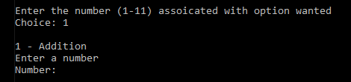

1.02

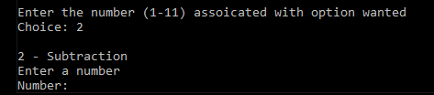

1.03

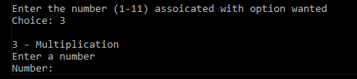

1.04

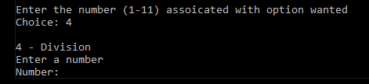

1.05

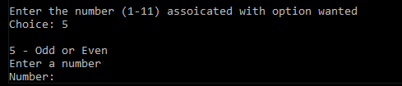

1.06

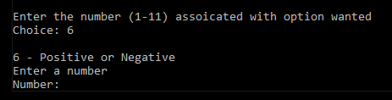

1.07

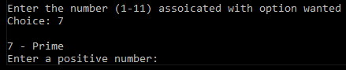

1.08

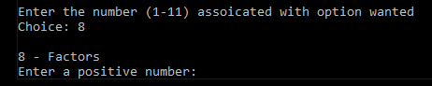

1.09

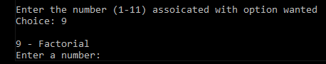

Test each menu item, which calls a function, to determine that each function performs their task correctly

1.01

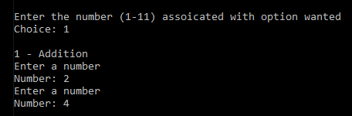

1.02

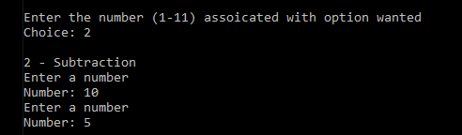

1.03

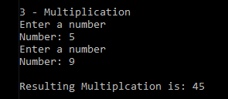

1.04

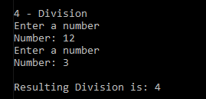

1.05

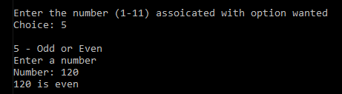

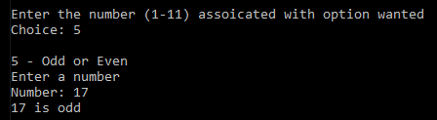

1.06

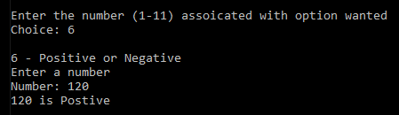

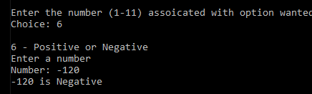

1.07

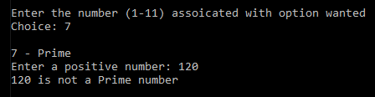

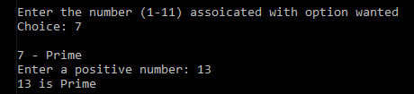

1.08

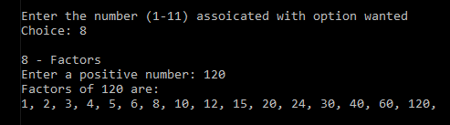

1.09

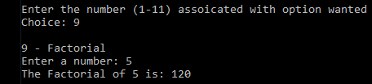

Choose exit choice to validate that menu exits correctly

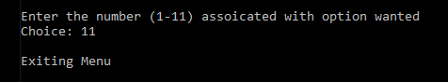

Test that an invalid choice in the menu results in an error message and redisplay of menu

2.01

